Water technology

Preparation of boiler feed water by ion-exchange desalination

Water hardness

There are several cations ( pl.: Na⁺, Ca⁺⁺, Mg⁺⁺, H⁺, K⁺, NH₄⁺, Fe⁺⁺, stb) and anions (Cl⁻, SO₄²⁻, NO₃⁻, PO₄³⁻, HCO₃⁻, CO₃²⁻ etc.) naturally occuring in freshwaters.
In ceratain cases, salts of calcium and magnesium behave differently from other cations. Calcium and magnesium ions cause water hardness.

These cause „scaling” in boilers, resulting in less efficient transfer of heat through heat exchanger surfaces. Scaling can also cause overheating of boiler parts under pressure thus reducing strength of pipes and other boiler parts, increasing danger of explosion. Heat transfer coefficient of scale layer is 15-20 times worse than that of steel, reducing boiler efficiency, resulting in excess energy consumption. 1 mm (carbonate-silicate) scaling reduces efficiency of a medium sized boiler by 3 to 5%. Scale layer can crack, thus water reaches the locally overheated pipe wall, suddenly becoming steam (explosion), this breaks boiler wall.
Scaling in pipes reduces cross-section or can even lead to complete clogging.

Carbonate Hardness (CH)
Dissolved calcium and magnesium hydrogen-carbonate cause the so called carbonate hardness.
These decompose when the water is boiled, producing solid calcium- and magnesium carbonate (scale):

Ca(HCO₃)₂ <-> CaCO₃ + H₂O + CO₂ és Mg(HCO₃)₂ <-> MgCO₃ + H₂O + CO₂

Non-carbonate Hardness (NCH)
All other water soluble salts of Ca and Mg. These are poorly soluble, thus produce precipitate (scale) as the solution is getting concentrated due to evaporation.

Total Hardness (TH)
The total hardness is the sum of the carbonate and non-carbonate hardness. TH= CH+NCH.

Expressions of water hardness
As hardness is casued by two types of cations with different anions, water hardness can only be determined in „equivalent units”. Hardness is expressed in CaO equivalents. This means that each mol of any salt causing hardness is equivalent to one mol of CaO, expressed as mg CaO/dm³ or mmol CaO/dm³.

Hardness calculation example
water analytics:
Ca(HCO₃)₂ 243 mg/dm³ (Carbonate hardness)
MgSO₄ 90 mg/dm³ (Non-carbonate hardness)
NaCl 120 mg/dm³ (Causes no hardness)

Carbonate hardness (CH)
1 mmol Ca(HCO₃)₂ = 162 mg, this is equivalent hardness to 1 mmol CaO = 56 mg
243 mg is equivalent hardness to X mg thus X=84 mg
So CH= 84 mgCaO/dm³ or CH= 243/162 = 84/56 = 1,5 mmol CaO/dm³

Non-carbonate hardness (NCH)
1 mmol MgSO₄ = 120 mg, this is equivalent hardness to 1 mmol CaO = 56 mg
90 mg is equivalent hardness to Y mg thus Y=42 mg
So NCH= 42 mgCaO/dm³ or NCH= 90/120 = 42/56 = 0,75mmol CaO/dm³

Total hardness (TH)
TH= CH+NCH = 84+42=126 mgCaO/dm³ or TH = 126/56 = 1,5+0,75 = 2,25 mmol CaO/dm³

The two most common technologies of eliminating hardness

1. Water softening
Softening means that Ca and Mg ions are replaced by Na ions, which does not cause hardness. This is done by the use of ion-exchange resins. An ion-exchnage resin is a fine, granulated material containing anions or cations. When softening water, cation-exchange resin is used. Water passes though a bed of a bed of cation-exchange resin, originally loaded with Na⁺ ions. These Na⁺ ions are released to the water from the surface of the resin and are replaced by Ca²⁺ and Mg²⁺ ions of equivalent electric charge (two Na⁺ for each Ca²⁺ or Mg²⁺ ion).

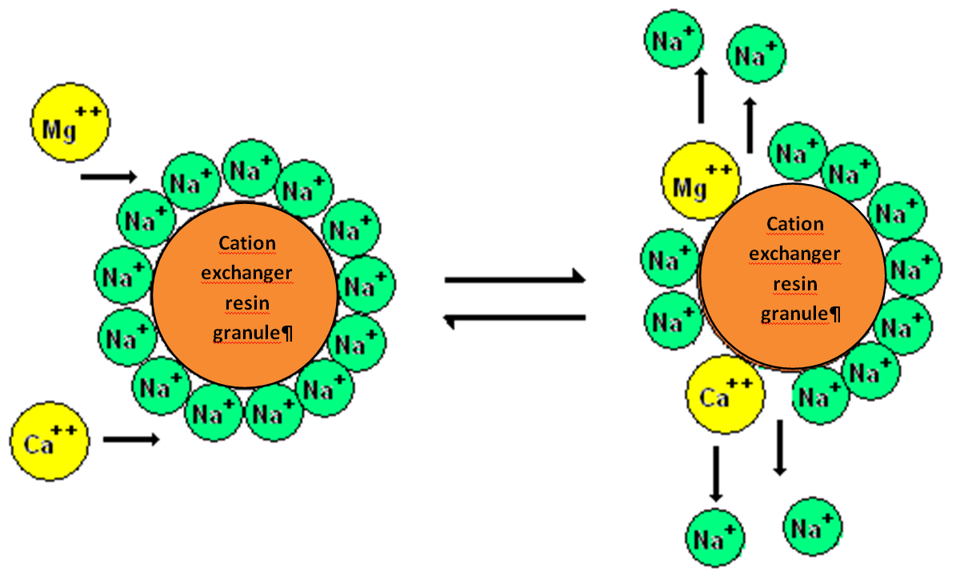
Figure 1. - Water softening with ion-exchange
Ion-exchange is an equilibrium process, thus exhausted resin (which lost its Na⁺ ions) can be regenerated with concentrated sodium ion solution (eg. a few mol/dm³ NaCl solution).

2. Complete desalination (production of deionised water)
When the aim is to produce feed water for high-pressure boilers, it is not enough to eliminate hardness, but all salts must be removed. In this process, water first passes through a cation-exchange resin, which is charged with H⁺ ions (instead of Na⁺).

Cation-exchange resin:
Resin-H
Resin -H
+ Ca⁺⁺
Resin
Resin
Ca + 2 H⁺
Anion-exchange resin:
Resin-OH + Cl⁻
Resin-Cl + OH⁻
Exhausted anion-exchange resin can be regenerated with concentrated NaOH solution
Exhausted cation-exchange resin can be regenerated with concentrated HCl solution.
In the cation-exchange unit all cations are replaced by H⁺ (water is acidic). This water then passes through an other unit, containing OH⁻ charged anion exchange resin, where all anions are replaced by OH⁻. H⁺ from the first unit and OH⁻ from the second unite to form water, this pH is neutralized. Due to the lack of ions, electric conductivity of the treated water is very low.

Production of deionised water for high pressure boilers
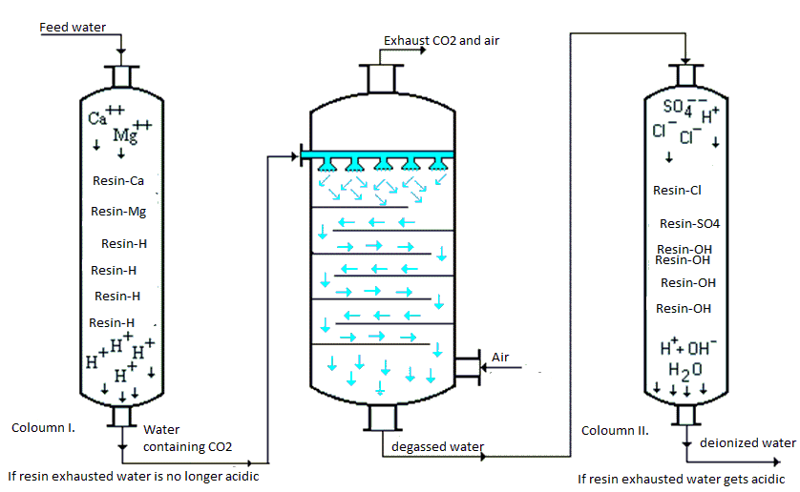
Order of the two ion exchange columns can not be changed, because OH⁻ produced in the anion-exchange unit would first form Ca(OH)₂ and Mg(OH)₂ precipitate which would damage the resin.
Figure 2.- Production of deionised water with ion-exchange resin

As shown in Fig. 2, a degassing coloumn is placed between the two ion-exchangers, because low pH water produced during cation-exchange causes liberation of CO₂ gas from carbonates. This is corrosive and can degrade anion-exchange efficiency due to bubbles formed in the resin bed (redicing resin contact surface).
H⁺ + HCO₃ ⁻ <-> CO₂ + H₂O

Ion-exchange capacity
In order to design ion-exchange unit size, it is important to know useful resin capacity. This is expressed in [molH⁺ion/dm³resin] units for cation-exchangers and [molOH⁻ion/dm³resin] for anion-exchangers.

How to determine ion-exchanger size
Question:
Useful capacity of a cation-exchanger resin is 1.4 mol H⁺/dm³. What quantity of water can be treated with this resin if the water hardness is 280 mg CaO/dm³, and the water does not contain other cations which do not cause hardness. What should be the size of the anion-exchanger resin bed to assure that both columns get exhausted at the same time? Useful capacity of the anion-exchanger resin is 0.7 mol OH⁻/dm³.
Answer:
280 mg CaO/dm³ equals 280/56 = 5,0 mmol CaO/dm³. This is equivalent to 10 mmol H⁺/dm³.
Useful capacity of 1 m³ cation exchange resin is 1*10³ dm³ * 1.4 mol/dm³ = 1,4*10³ mol.
Each m³ of water passing through the bed consumes 1*10³ dm³ * 10 mmol/dm³ = 10 mol.
Until the breakthrough point 1,4*10³ mol/10 mol = 1,4 * 10² m³ water can be treated with this resin.
Useful capacity of the anion-exchanger resin is 0,7/1,4 = 0,5 thus half of the capacity of the other resin. If the aim is to exhaust the two types of resins simultaneously, we need to apply twice the amount of the cation exchanger for the anion exchanger. This is 2 m³.

Laboratory exercise

Complete desalination (deionisation) of tap water is tested with a H⁺ charged cation-exchager and a OH⁻ charged anion-exchanger connected in series.
Cation exchanger: 6 cm3 highly acidic cation exchange resin (Varion KS) in H⁺ form, filled in a 1,8cm diameter glass coloumn
Anion exchanger: 8 cm3 highly acidic cation exchange resin (Varion AD) in OH⁻ form, filled in a 1,8cm diameter glass coloumn
A degassing coloumn is connected between the two ion-exchangers.
Electric conductivity and pH is measured in flow-through cells after each coloumn.

Normal operation:
Water leaving the cation-exchanger: high conductivity, low pH
Water leaving the anion-exchanger: low conductivity, natural pH
If cation exchange is exhausted first:
Water leaving the cation-exchanger: conductivity and pH equals to that of tap water
Water leaving the anion-exchanger: high conductivity, high pH
If anion exchange is exhausted first:
Water leaving the cation-exchanger: high conductivity, low pH
Water leaving the anion-exchanger: high conductivity, low pH

To do:
- Start water pump (and open taps), tart stop watch
- First readings to record: 1 min
- Data to record: treated water volume, conductivity and pH after each ion-exchanger.
- Continue reading every 3 mins.
- Continue operation as long as signs of ion-exchanger exhaust appear (see above)
- Make graphs of pH and conductivity versus treated water quantity for each coloumn.
- Determine which exchanger got exhausted first
- Determine useful ion-exchang capacity of the exhausted coloumn in [mmolH⁺/dm³] or [mmolOH⁻/dm³] units, supposing a tap water composition as follows: CaCl₂: 100 mg/dm³
MgCl₂: 300 mg/dm³
NaCl: 50mg/dm³
Atomic mass: Ca: 40, Mg: 24, Na: 23, Cl: 35.5
- Using the above water analysis data, calculate hardness both in mgCaO/dm³ and mmolCaO/dm³ units.

Test questions:
- What causes water hardness?
- What type of salts cause carbonate and non-carbonat hardness?
- How to calculate total hardness?
- Name a water soluble salt tha does not couse hardness.
- Ca/HCO₃/₂, MgCl₂, KCl, CaCl₂, Ca/NO₃/₂. Which of these does not cause hardness?
- What is „water softening”?
- What is the difference between water softening and complete desalination (deionisation)?
- Describe operation of anion-exchange resin?
- Describe operation of cation-exchange resin?

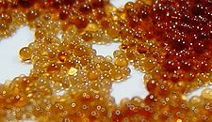

ion-exchange resin granules (magnified)
average granule size Ø ≈ 1 mm

